

East West University

Department of Computer Science & Engineering

**Course Title:** Database System

**Course Code:** CSE301  
**Experiment No:** 06

**Semester:** Fall, 2015

**Section:** 01

**Submitted By:**

S. M. Amirul Islam

ID: 2013-1-60-048

**Class work**

**Create table:**

createtable employee(

ename varchar(20),

street varchar(20),

city varchar(20),

)

createtable works(

ename varchar(20),

cname varchar(20),

salary numeric(9,3),

jdate datetime,

)

createtable company(

cname varchar(20),

city varchar(20)

)

droptable company

createtable manages(

ename varchar(20),

mname varchar(20)

)

**Insert data:**

insertinto employee values('Rahim','X','Dhaka');

insertinto employee values('Mity','Y','Sylhet');

insertinto employee values('Sabbir','z','Ctg');

insertinto employee values('Babu','p','Dhaka');

insertinto employee values('Toma','X','Bogra');

insertinto employee values('Jabbar','X','Comilla');

insertinto works values ('Rahim','First B.C',20000,'8/8/2008')

insertinto works values ('Mitu','Small B.C',30000,'8/13/2008')

insertinto works values ('Sabbir','Square Pharma',40000,'9/17/2008')

insertinto works values ('babu','GP',50000,'12/31/2008')

insertinto works values ('Toma','Square',35000,'10/10/2008')

insertinto works values ('Jabbar','First B.C',15000,'4/4/2008')

insertinto company values ('First B.C','Dhaka');

insertinto company values ('Small B.C','Sylhet');

insertinto company values ('Square Pharma','Ctg');

insertinto company values ('GP','Rajshahi');

insertinto manages values('Rahim','Sabbir');

insertinto manages values('Mitu','Babu');

insertinto manages values('Toma','Oronno');

insertinto manages values('Salam','Jabbar');

**Ques1:**

Select cname from company where cname like'__'

output:

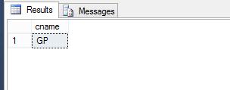

**Ques2:**

Select ename from employee where enamelike'______%'

Output:

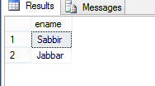

**Ques3:**

select*from employee where ename like's%'

output:

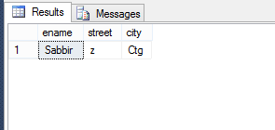

**Ques4:**

select*from employee where ename like'%m'

output:

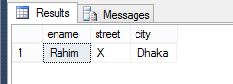

**Ques5:**

Select * from employee where name like 'R%m'

output:

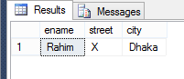

**Ques6:**

Select * from employee where ename like 'J%'

output:

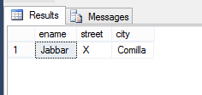

**Ques7:**

Select * from employee where ename like '%b%'

output:

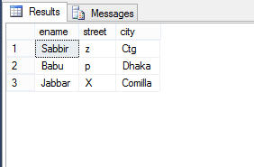

**Ques8:**

Select * from works orderby salary asc

output:

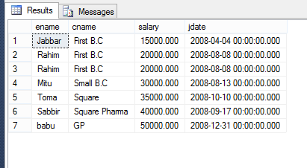

**Ques9:**

Select * from works orderby salary desc

output:

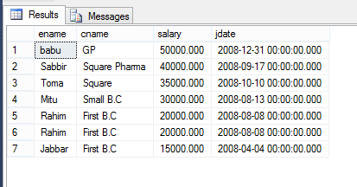

**Ques10:**

Select * from works orderby salary asc,ename desc

**output:**

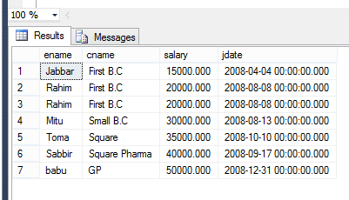

**Ques11:**

Select ename from works where cname='First B.C'

output:

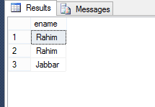

**Lab Exam**

Table creation:

createtable book(

ISBN int,

Title varchar(20),

Price int,

Publisherid int

)

createtable publisher(

publisherid int,

pname varchar(20),

paddress varchar(20)

)

createtable author(

authored int,

author_name varchar(20),

address varchar(20)

)

Create table author_book(

ISBN int,

Authored int

)

**Data Inserte:**

Insert into book values (4125,'abc',120,1);

Insert into book values (7412,'databse',253,2);

Insert into book values (3256,'network',183,1)

Insert into book values (7456,'math',213,3);

Insert into book values (7458,'physics',745,1);

droptable book

insert into publisher values (1,'narosa','dhaka');

insert into publisher values (2,'macgill','newyork');

insert into publisher values (3,'pearson','canada');

insert into publisher values (4,'alfred','delhi');

insert into author values (124,'asif','dhaka');

insert into author values (2354,'ana','newyork');

insert into author values (142,'devid','osaka');

insert into author values (1258,'jhon','canada');

insert into author_bookvalues (4125,124);

insert into author_bookvalues (7412,124);

insert into author_bookvalues (3256,142);

insert int oauthor_bookvalues (7456,1258);

insert into author_bookvalues (7458,142);

**1:**

selectaddressfrom author whereaddresslike'_____'

Output:

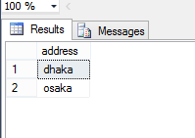

**2:**

selectaddressfrom author whereaddresslike'______'

Output:

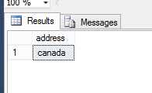

**3.**

Select paddress from publisher wherepaddresslike'______%'

Output:

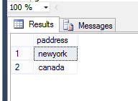

**4.**

Select author_name from author where author_name like'a%'

Output:

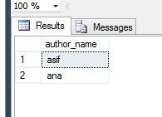

**5.**

Select author_name from author where author_name like'a%a'

Output:

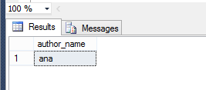

**6:**

Select author_name from author where author_name like'%n'

Output:

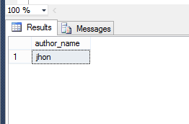

**7.**

Select paddress from publisher where paddress like'd%'

Output:

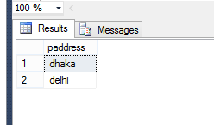

**8:**

Select *from book orderby ISBN asc

Output:

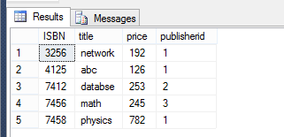

**9.**

Select * from book orderby ISBN desc

Output:

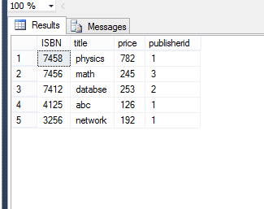

**10.**

select*from book orderby price asc,ISBNdesc

Output:

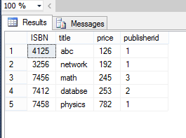

**11.**

update book set price=price*1.05 wherepublisheridin(selectpublisheridfrom publisher wherepname='pearson')

select*from book

Output:

Before Update: 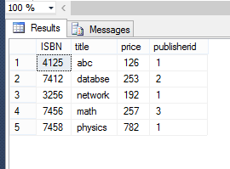

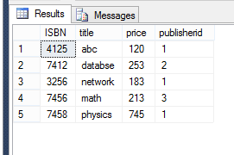

**12.**

Select book.ISBN,book.title,book.price from book join author_bookonbook.ISBN=author_book.ISBN join author on author_book.authorid=author.authorid whereauthor.address='Dhaka'

Output:

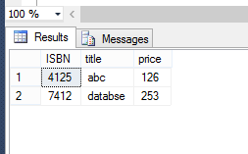

**13.**

update book set price=price*1.05 where publisheridin(select publisherid from publisher where paddress='dhaka')

select * from book

Output:

Before Update:

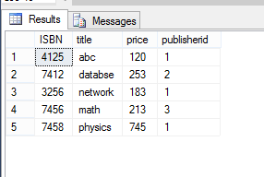

After Update:

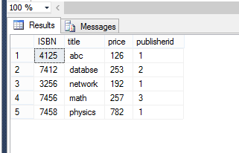

**14.**

Selec tbook.ISBN,book.title from book join author_book on book.ISBN=author_book.ISBN join author on author_book.authorid=author.authorid where author.author_name='jhon'

Output:

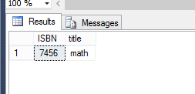

**15.**

select price from book where title='physics'

Output:

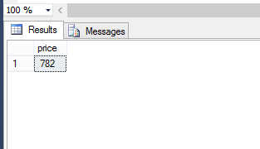

**Discussion:** In this lab I have learnt the basic ideas of database management system and string operation of database and about order by operation.